
Kairos Form 002: Previous Homeschool Records

Introduction
Previous high school homeschool records completed by your children before enrolling with HLA through Kairos are evaluated and considered for transfer to their respective HLA Transcripts. Please use this document to provide a summary of these previously completed subjects (credits).

Instruction for completion

The form allows for the inclusion of Grades 8-11 homeschool subjects, with three years of transfer credits covered in “HLA’s Transfer & Transcription” fee.

For Grade 8, HLA will accept up to three high school (Grade 9 or higher) credits for Social Studies, Maths, and/or Science.
- Please complete all fields highlighted in light blue, and complete the form for the transferring grades.
- Be sure to provide a grade and credit for EACH subject.
- Ideally use percentages for each subject.

Enter information in English; for Afrikaans resources, include the title in quotes (preferably with an ISBN).

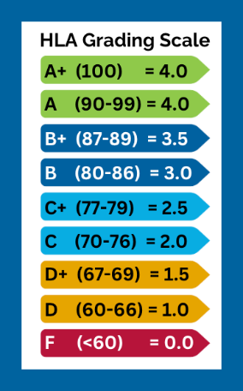
HLA recommends a maximum of 8 credits per student per grade year.
- Consistently apply this HLA grading scale for EACH subject when reporting progress:
- Please return to Kairos.academysa@gmail.com upon completion (separate form per
child).

Definitions
- Credits:
  - Applies only to Grade 9 or higher subjects for students in Grades 9-12.
  - Early credits for Grade 8 apply only to Grade 9+ courses in Maths, Science, or Social Studies.
  - 1 credit = a full year high school course, OR a 3- or 4-credit dual enrollment /
  - credit course, OR 150 hours of an undefined credit course (e.g. PE) completed
  - 0.5 credit = half of a full year, OR a full semester course, OR 75 hours+ of an undefined course completed
- Semesters:
  - Spring Semester: January – 15 June
  - Fall Semester: July – 15 January
  - Summer Semester (only US calendar families): 16 June – July / Aug / Sept.
- Transfer Fee:
Covers the transfer of 3-years of previously completed high school (Gr9 and higher) subjects.
- Homeschool Records:
Records of subjects completed independently at home, not through an accredited school or academy. This includes online resources like Time4Learning, Impaq, Think Digital, etc.

Your information
Name & Surname of the person completing this form
Date of completion

Next steps
Once your documentation is received, it will undergo an internal review before being submitted to HLA for assessment and inclusion on Applecore. Delays may occur if information is incorrect or incomplete.

Homeschool High School Records for transfer to HLA

Student Name & Surname:
Grade: |  | 8 (if applicable)
Year Grade was completed:
No | Subject area | Subject Title | % | Credit claimed | Resources used
e.g. | Mathematics | e.g. Algebra I | 83% | 0.5 | e.g. Teaching Textbooks
1 | Mathematics
2 | Science
3 | Social Science
Homeschool High School Records for transfer to HLA

Student Name & Surname:
Grade: |  | 9
Year Grade was completed:
No | Subject area | Subject Title | % | Credit claimed | Resources used
e.g. | English | e.g. English 09 | 90% - | 1 | e.g. LLATL Grey
1 | English
2 | Foreign Language
3 | Mathematics
4 | Science
5 | Social Science
6 | Physical Education
7 | Elective
8 | Elective
9 | Elective
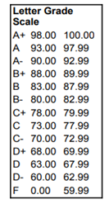
Homeschool High School Records for transfer to HLA

Student Name & Surname:
Grade: |  | 10
Year Grade was completed:
No | Subject area | Subject Title | % | Credit claimed | Resources used
e.g. | Science | e.g. Biology with lab | 90% | 1 | e.g. Exploring Creation with Biology, Dr J. Wile
1 | English
2 | Foreign Language
3 | Mathematics
4 | Science
5 | Social Science
6 | Physical Education
7 | Elective
8 | Elective
9 | Elective
Homeschool High School Records for transfer to HLA

Student Name & Surname:
Grade: |  | 11
Year Grade was completed:
No | Subject area | Subject Title | % | Credit claimed | Resources used
1 | English
2 | Foreign Language
3 | Mathematics
4 | Science
5 | Social Science
6 | Physical Education
7 | Elective
8 | Elective
9 | Elective

Applicable only if your student has completed high school (Grade 9+) level work in Mathematics (e.g., Algebra I), Science (e.g., Physical Science), or Social Studies (e.g., World History).

